User’s Guide

Mouseville

BEN NG, ABHANG SONAWANE, NEHA CHOUDHARI, CURTIS WILSON, NAYAN KHODKE

2014

**Revision History**

|  |  |  |  |
| --- | --- | --- | --- |
| Name | date | reason for change | version |
| Ben Ng | 4/18/2014 | Initial Draft | 1.0 |

**Introduction**

The purpose of the Mouseville application is to provide a portable and user-friendly data collection and viewing application tool for breast cancer researchers at the Wexner Medical Center. This guide will explain how to use the application to perform common tasks like data input, editing, and search, among other things.

**Supported iOS Versions**

The Mouseville application was developed specifically for the iPad running the iOS 7.X operating system. While it’s possible that this application may be run on versions lower than 7.X, it is unadvisable, as it has not been tested on anything beneath it.

**Adding genotypes**

To add genotypes to the application, navigate to the home screen, where all the available racks are viewable. Touch the gear icon in the upper left corner of the app to be taken to the genotype menu.

**To add a new gene,** touch the “Add a New Gene” button and type in the name of the gene you wish to add then press okay.

**To delete genes,** touch the edit option in the upper right corner of the screen, select the gene you wish to delete, and touch again to confirm the deletion. Note that this cannot be undone. Press the done button where the Edit button was before when you are done deleting genes.

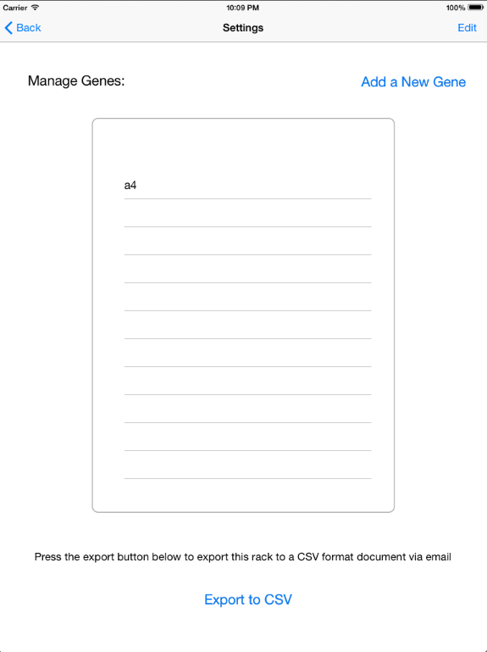

**Adding racks**

To add a rack, navigate to the home screen. Touch the plus sign in the upper right corner of the screen to navigate to the new rack menu. Type in the desired name and rack dimensions (max 7x10) and touch the “Create” button when finished.

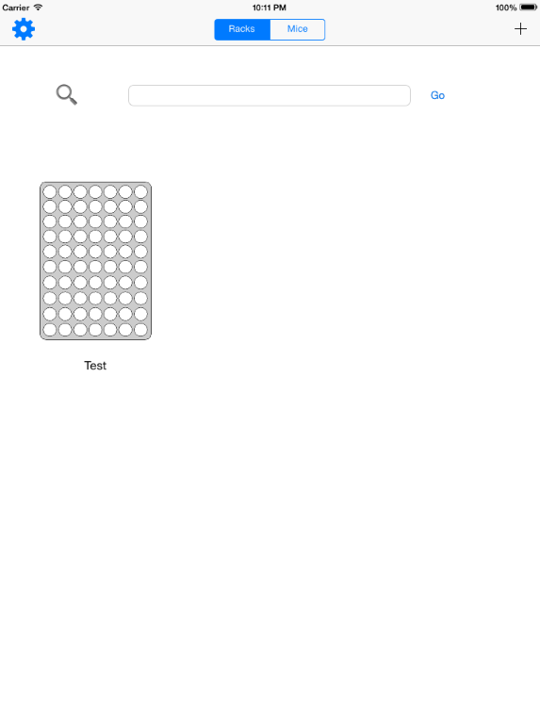 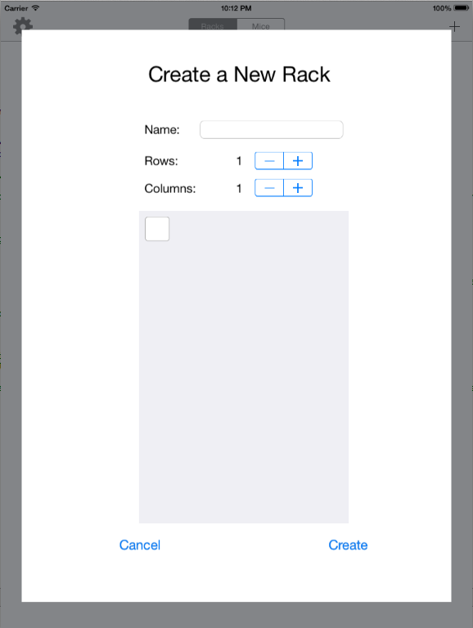

**Modify rack labels**

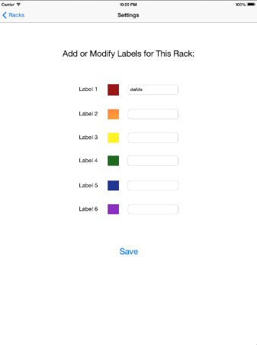You may modify rack labels by navigating into a rack that has already been created, and touching the settings button in the upper right corner of the screen. Select the label name you’d like to edit, and type in the desired name. Press save when finished.

These label names will appear in the cage details that will be discussed in the next section.

**Editing cage details**

Editing cage details can be done by navigating to the cage view within the desired rack, and then picking the cage you wish to edit.

Within the single rack view, click the edit button in the first section near the cage name. This allows you to change the name of the cage as well as input custom notes about the cage. Below that are the labels we mentioned in the previous section. Turning these labels on and off will change what you see when you zoom out to see the rest of the cages.

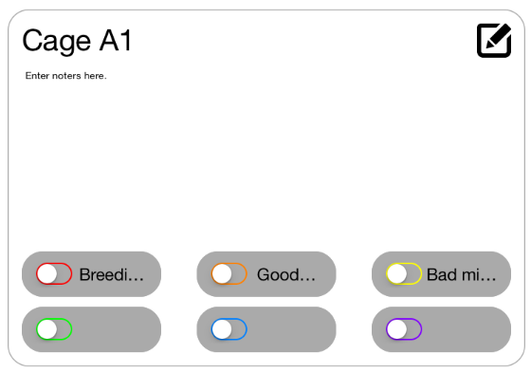

**Adding mice**

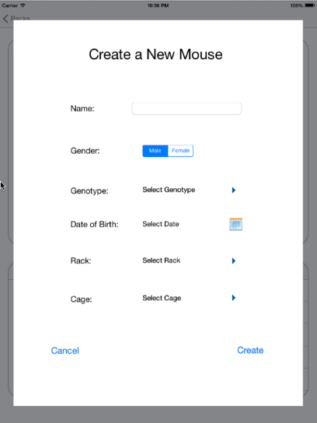Mice may be added by navigating to the cage view mentioned in the previous section and pressing the plus sign in the upper right corner of the “Mice” section.

Input the desired name, gender, genotype, date of birth, and rack/cage position. Touch “Create” when you are finished.

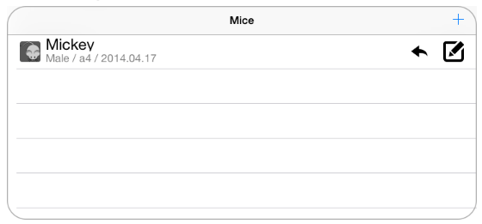

**Editing mice details**

Existing mice may be edited by navigating to the same screen you used to create the mouse. However instead of touching the plus button, press the edit button in the row of the mouse you wish to edit. This brings up a screen very similar to the new mouse screen, which you’ve seen before. Simply edit the details you wish to change and press save when you’re finished.

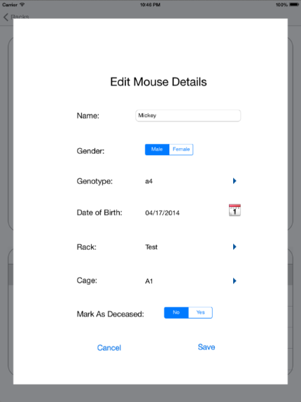

**Moving mice**

To move a mouse to another cage within its current rack, navigate to the cage details view and go to the mouse that you wish to move. Touch the arrow button next to the edit option, and touch the cage you wish to move the mouse to.

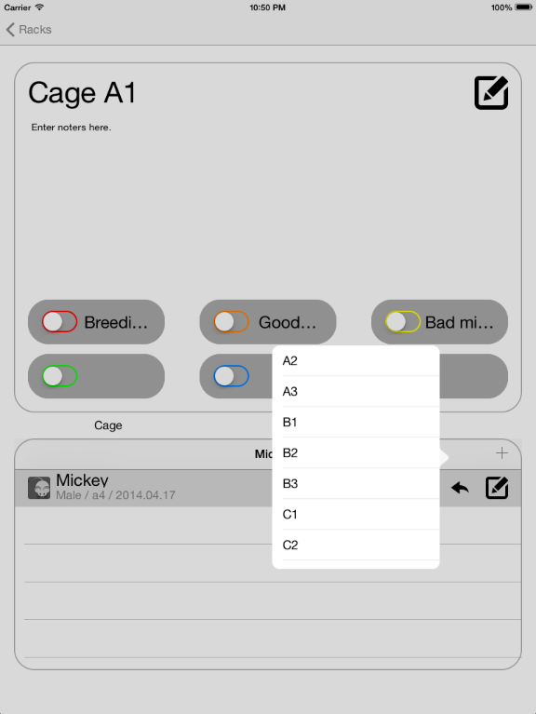

**Search racks**

To search through your racks, navigate to the home screen and make sure the tab at the top has “Racks” highlighted. Type in the rack you would like to search for in the search bar and touch “Go”

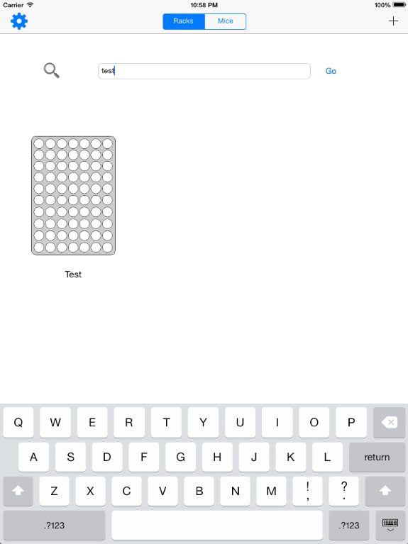

**Search mice**

To search through your mice, navigate to the home screen and change the tab from “Racks” to “Mice” at the top of the screen if it isn’t already. You may use the basic search if you know the name of the mouse you’d like to locate, or use the advanced search if you would like to add more search parameters.

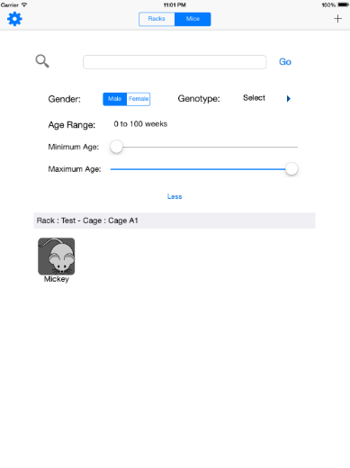

**Export to CSV**

To export to a CSV file, navigate to the home screen and touch the gear icon, just as you did to add genotypes to the application. However instead of adding genes, look down to the bottom of the screen and touch the “Export to CSV” button. The application will automatically start an email and attach the database in the form of a CSV file. Enter the desired recipients and subject, then press send when you are ready to send the CSV file.

